4/21/2016

RIGARD Simon

Heartbeat Simulator

**Microcontroller Version:**

This assignment is a heartbeat simulator and monitor, it calculate the bpm every 5 secs and tell the user if there is an alert, in other words, if the bpm is normal or critical.

Right below is the representation of what normal users and admin can do :

First, we begin by putting the username, if the username is not the admin account, the user is allowed to simulate and log out only. In the other case the user must put the password witch is currently “admin”.

After the authentication, the admin can choose to simulate a heartbeat, to see the log, to reset the log and to log out.

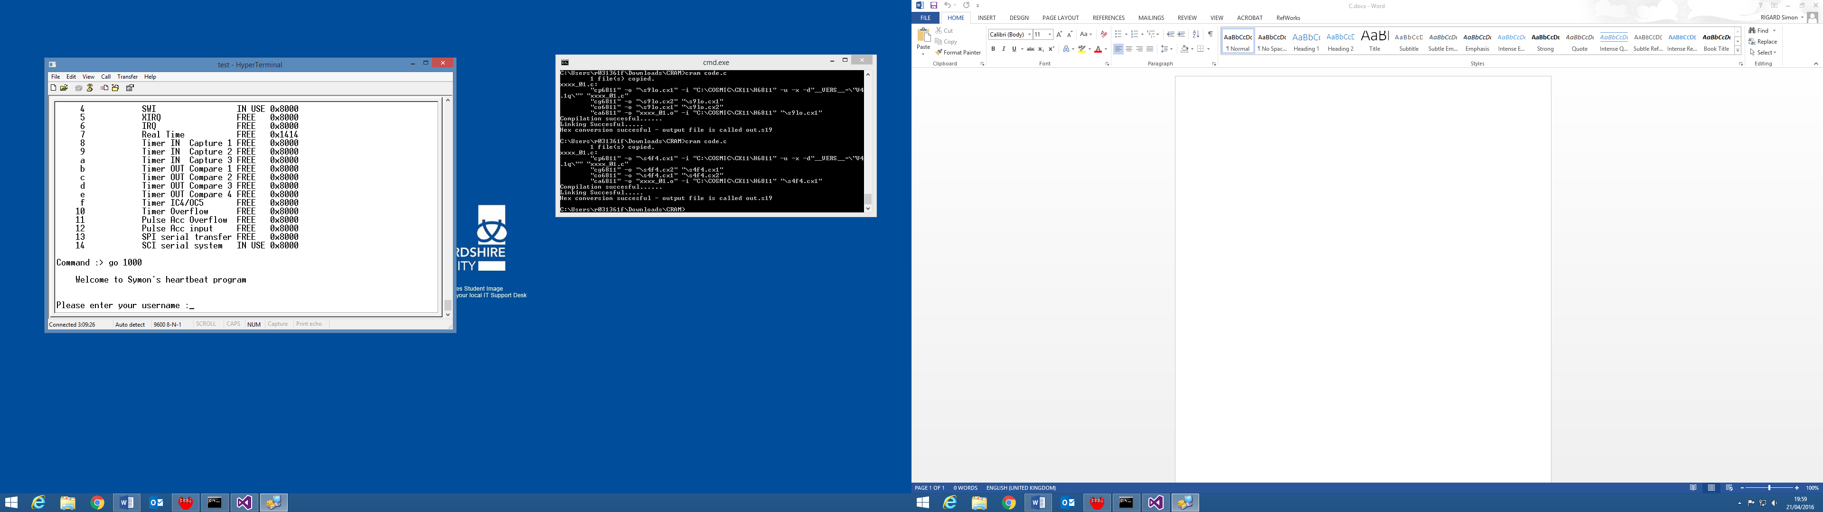

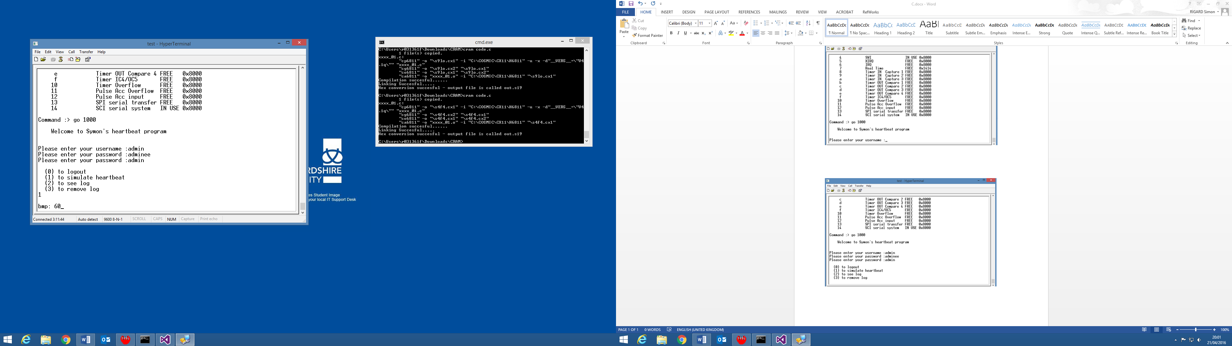

The simulation begins when the user puts 1 in the console. The actual bpm is printed on the same line every 5 seconds and the user can stop the simulation at any time just by pressing Enter on his keyboard.

To have the timer working, we must put the good value contained in map.map with “svec 7 value”. To calculate the bpm the program check if the values are sufficiently high and if they are decreasing.

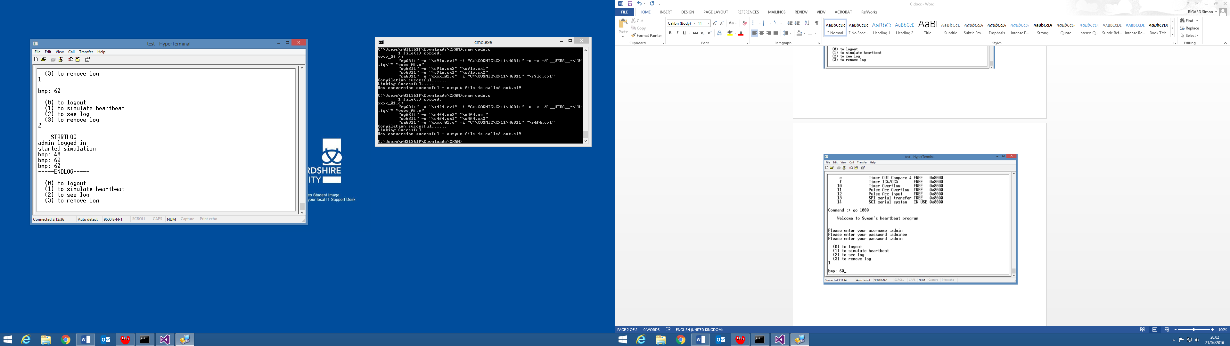

If the admin enters 2, the log is printed on the screen including these informations . Who logged on, logged out, when the simulation has started and the values of the bpm.

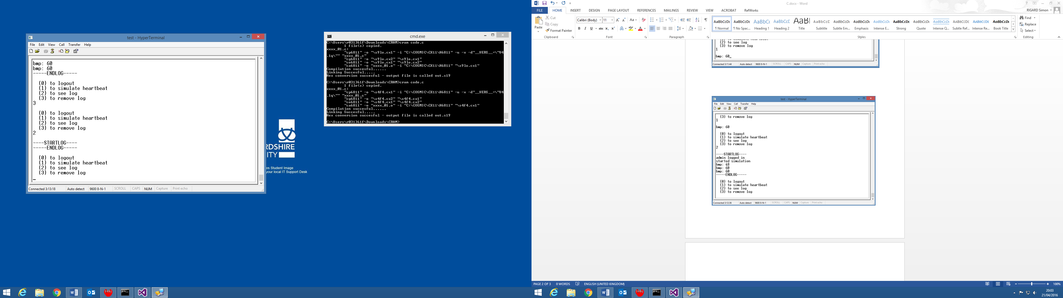

The log can also be removed like we can the in the image just above. If we print it afterwards, the log file is empty.

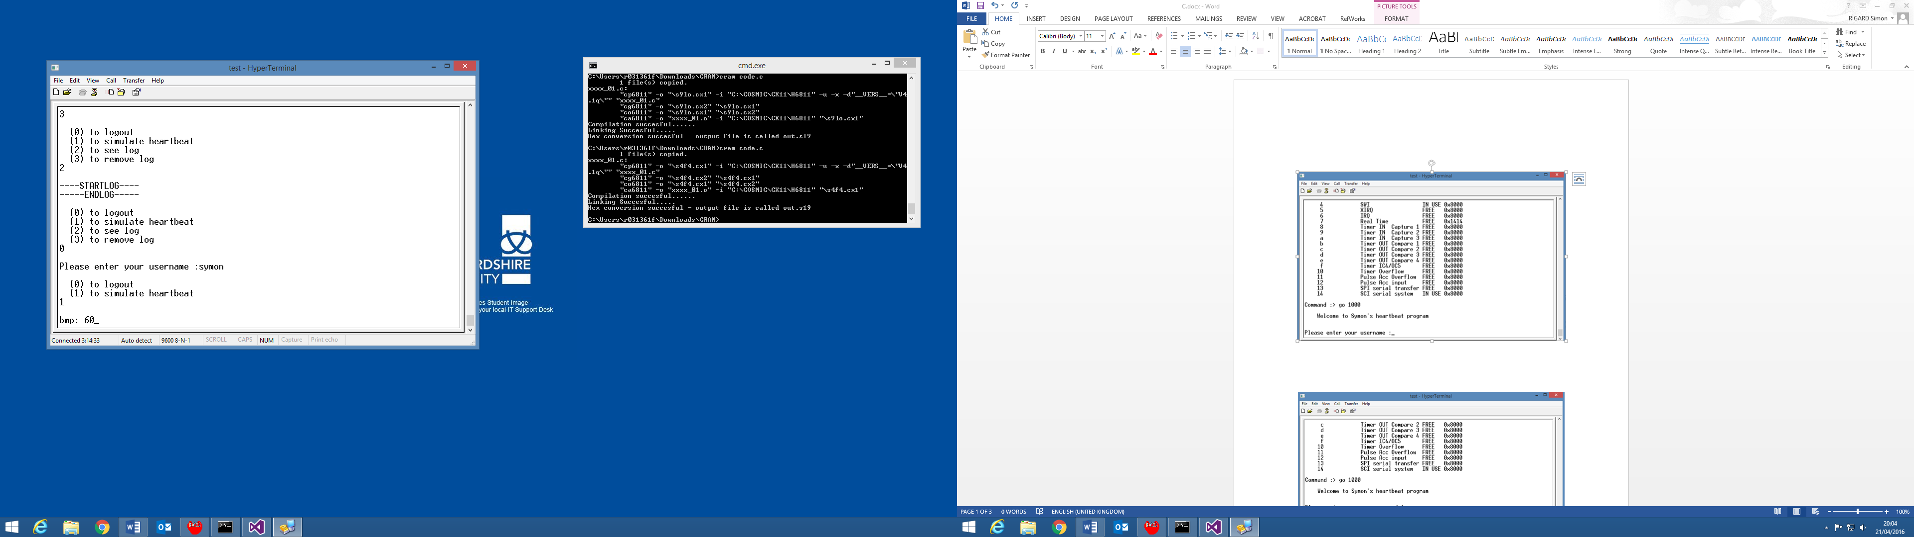

When the user log out, it is recorded on the log file and the user can log into another account like the admin account. No matter what account the user will take, he will always be able to simulate a heartbeat and change the different states through the ECG program.

**PC Version:**

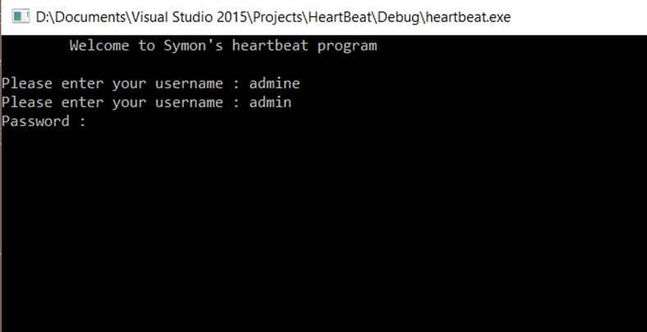

In the pc version the user can also log on with but he needs his username and his password. In fact, every user has a password stored in a txt file (pass.txt).

The program will check if the account exists and then if the password matches before letting the user simulate a heartbeat.

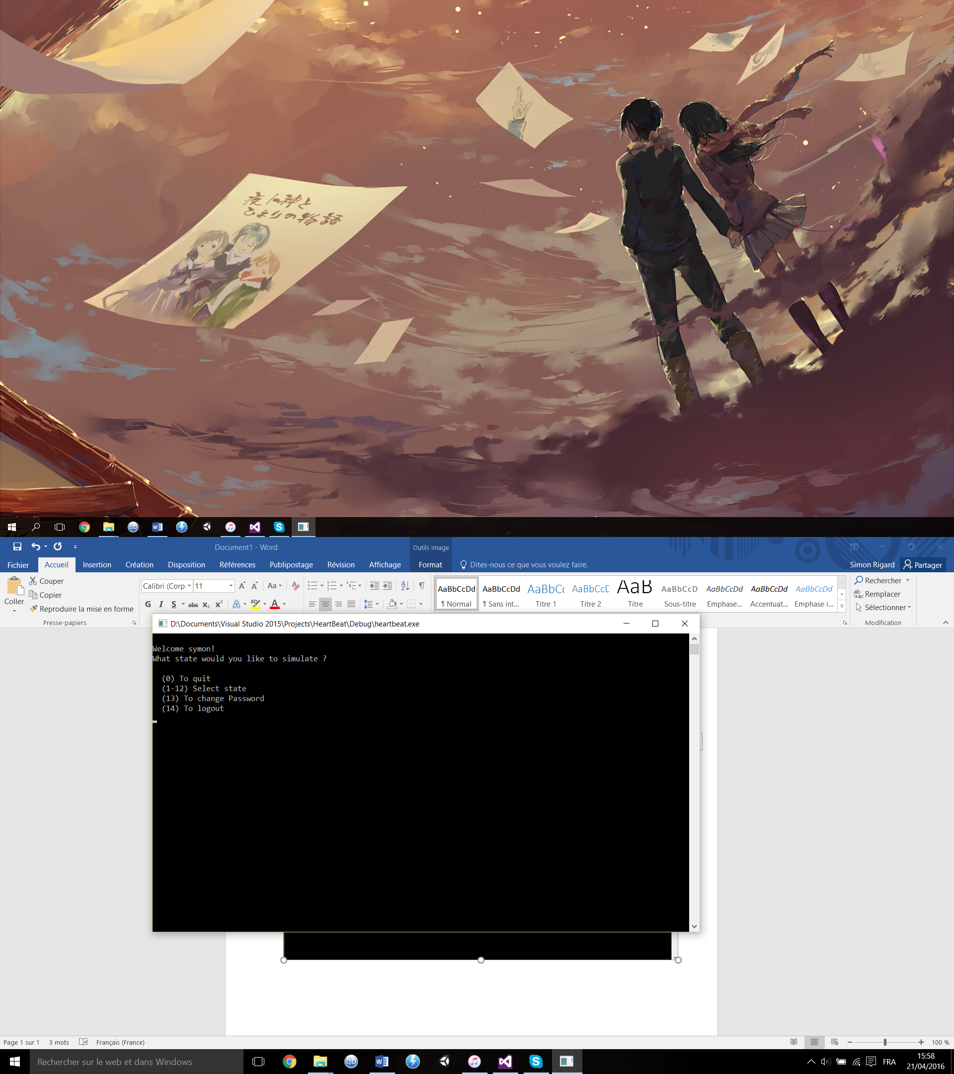

Every user can select the state he wants to simulate, change his password or log out. For example, here “symon” is the account and “pass” the password. If you want to use the program, you must have the file pass.txt with “user password” for each account on different lines

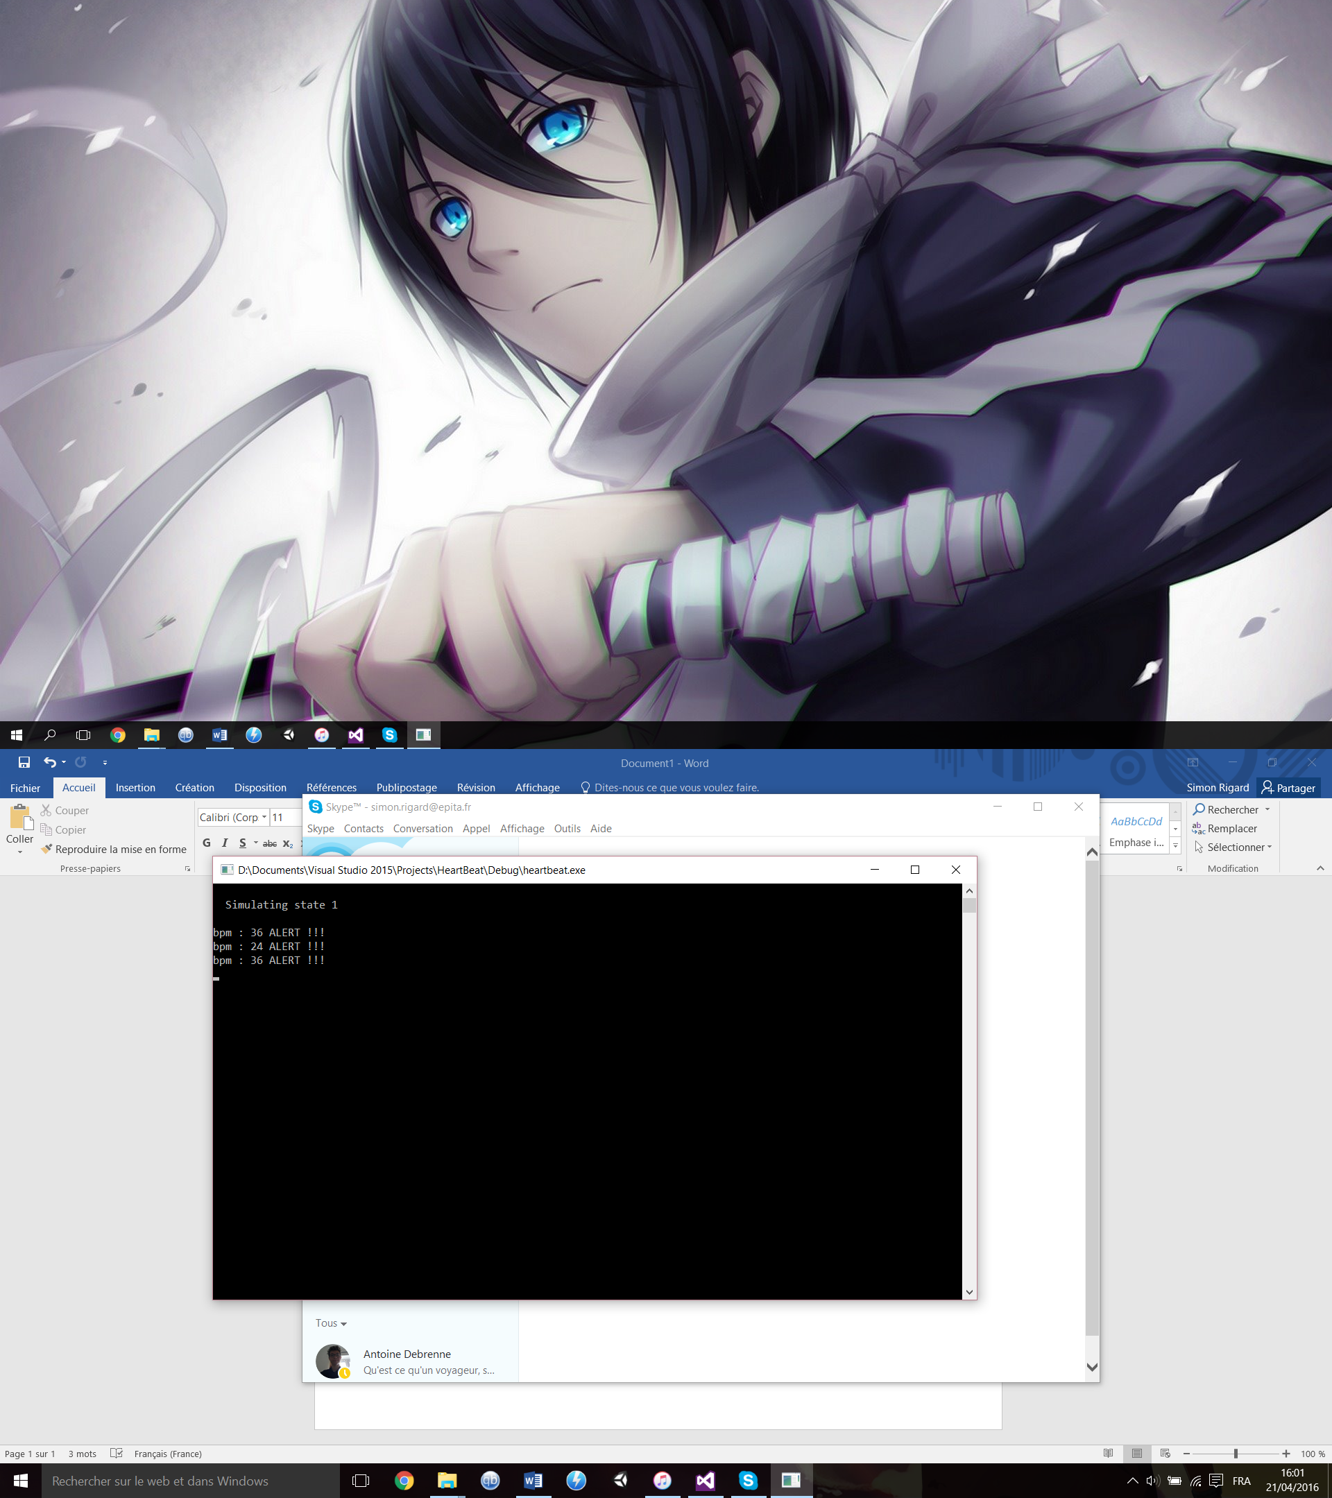

Every 5 seconds the program will calculate the bpm and print it on the screen. If the bpm is above 100 or below 40, the program will print “ALERT !!!”.

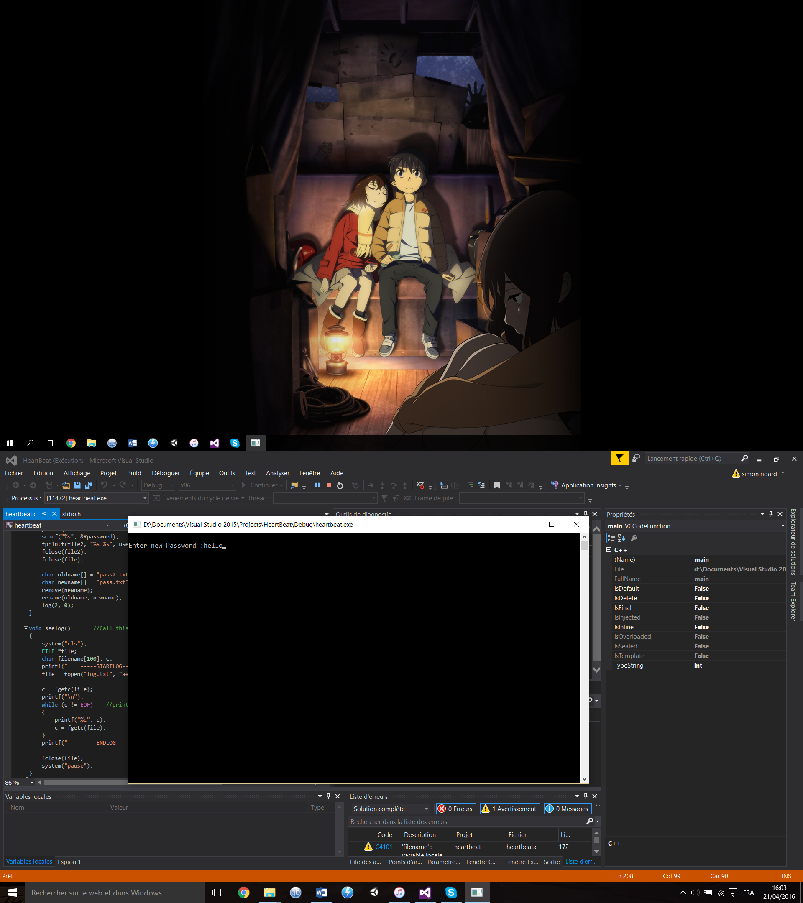

The user and the admin can change his password; it will be stored in the “pass.txt”.

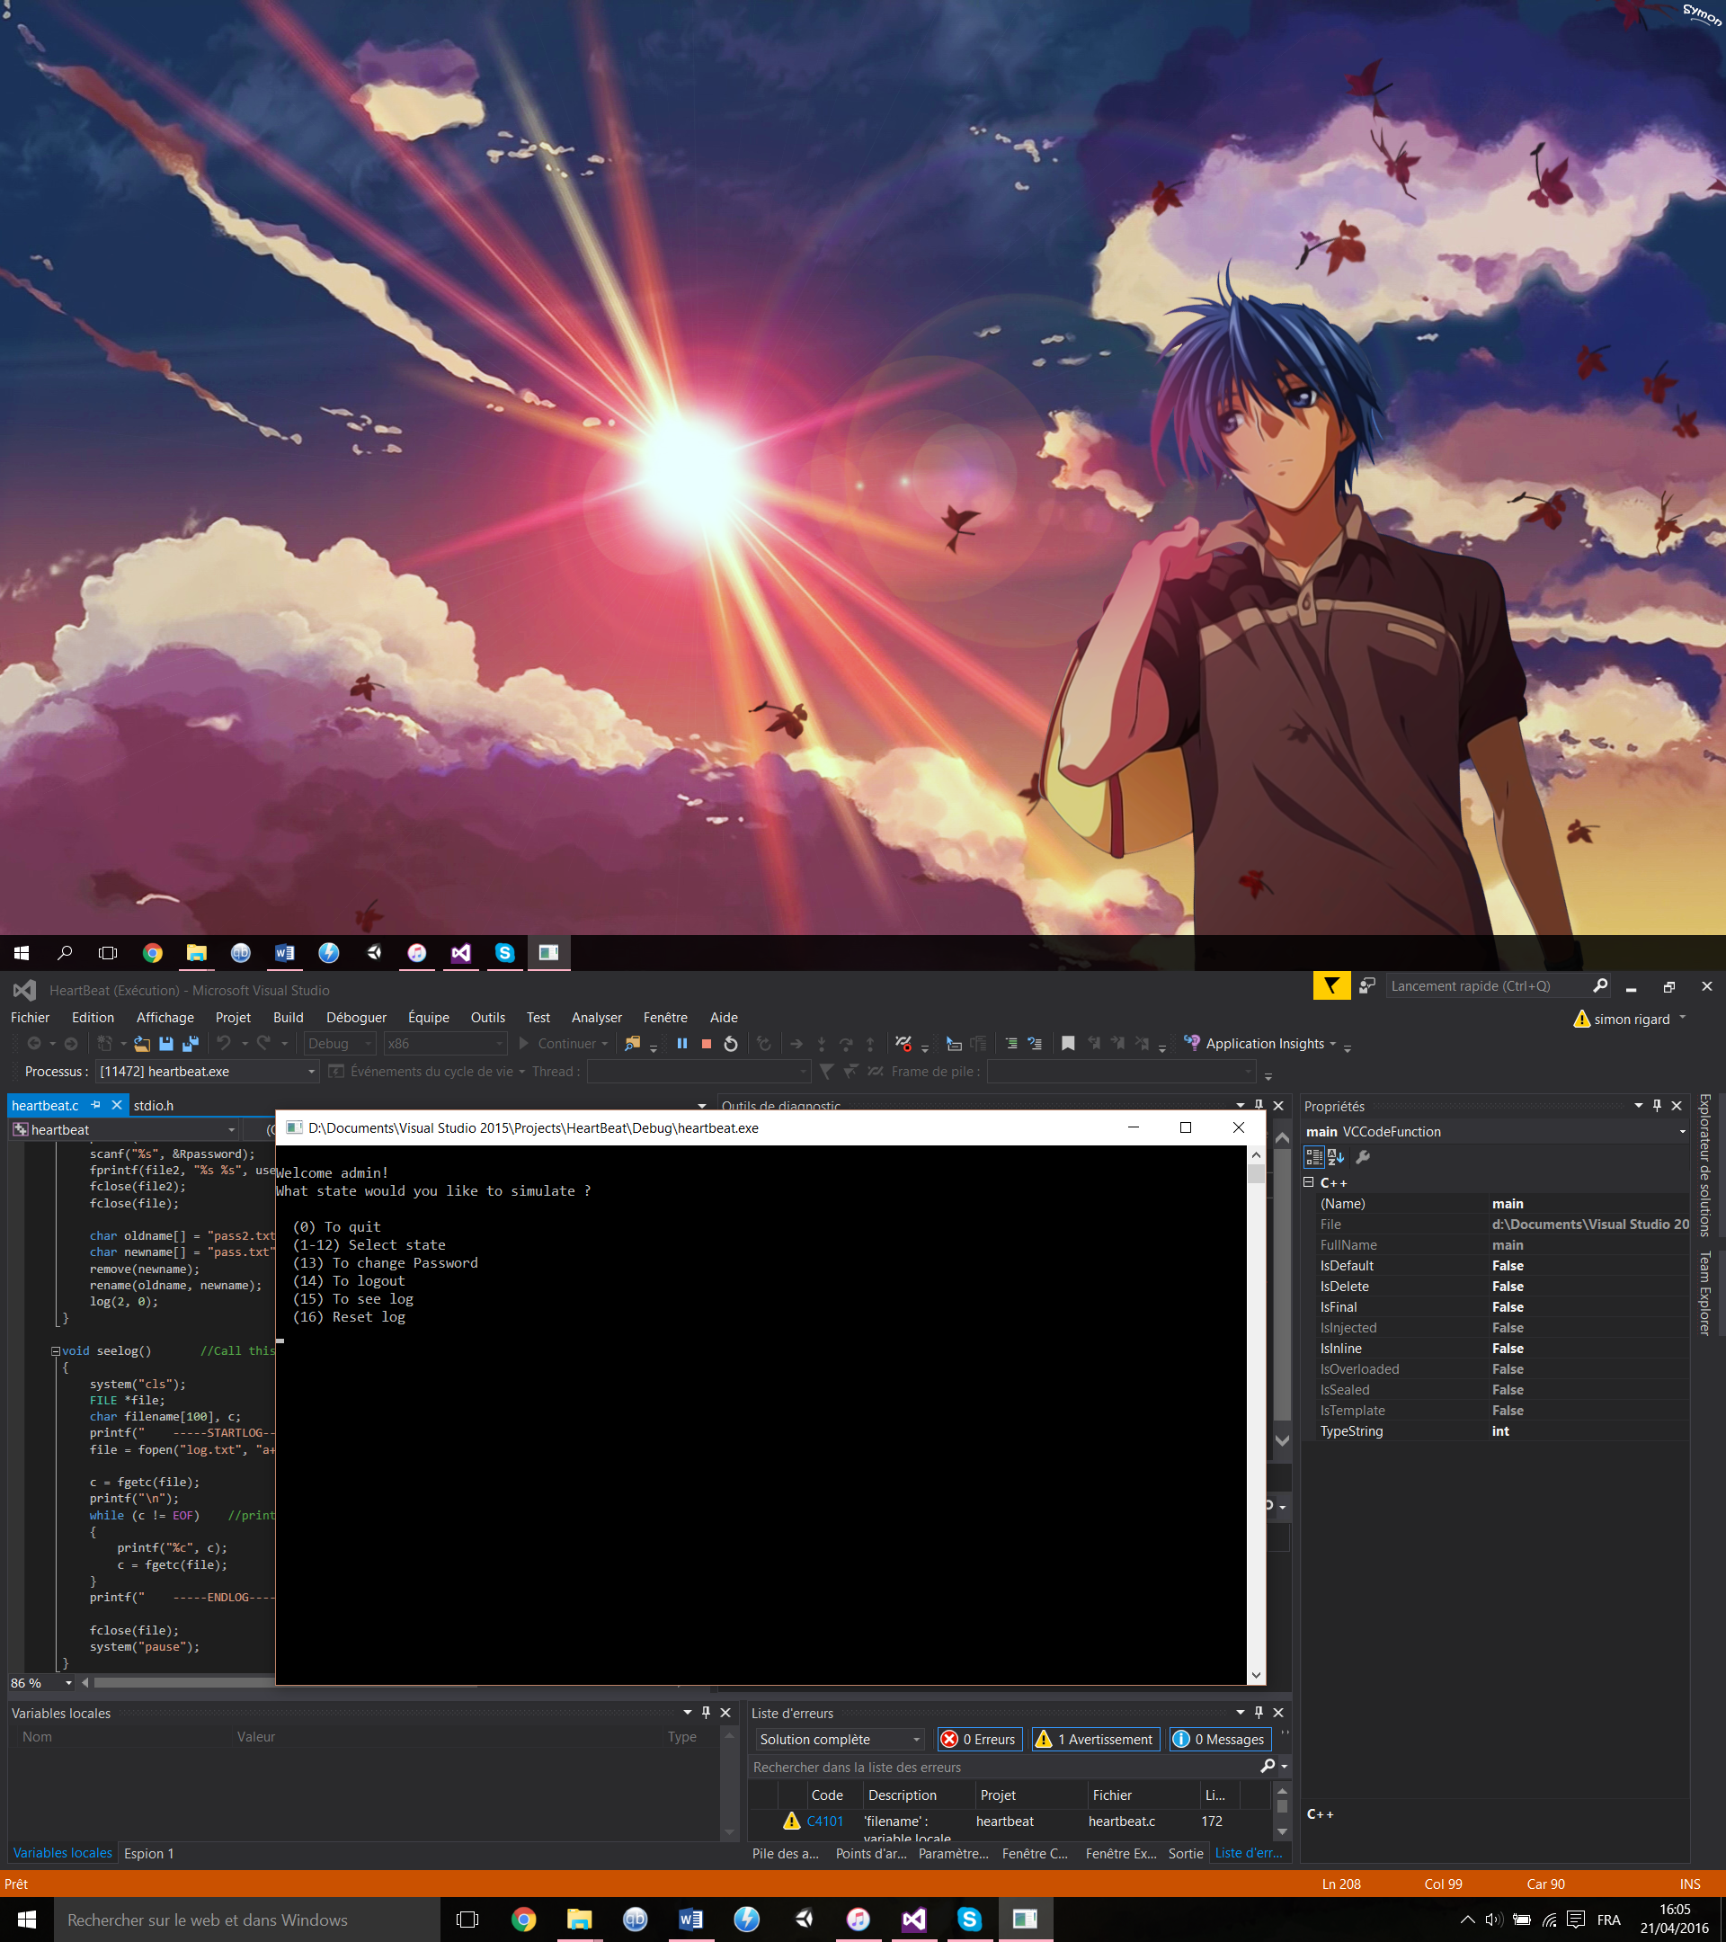

The admin can also see the log file, stored in “log.txt”. Inside everything the user is doing is stored whit the date and time. The function prints the log file.

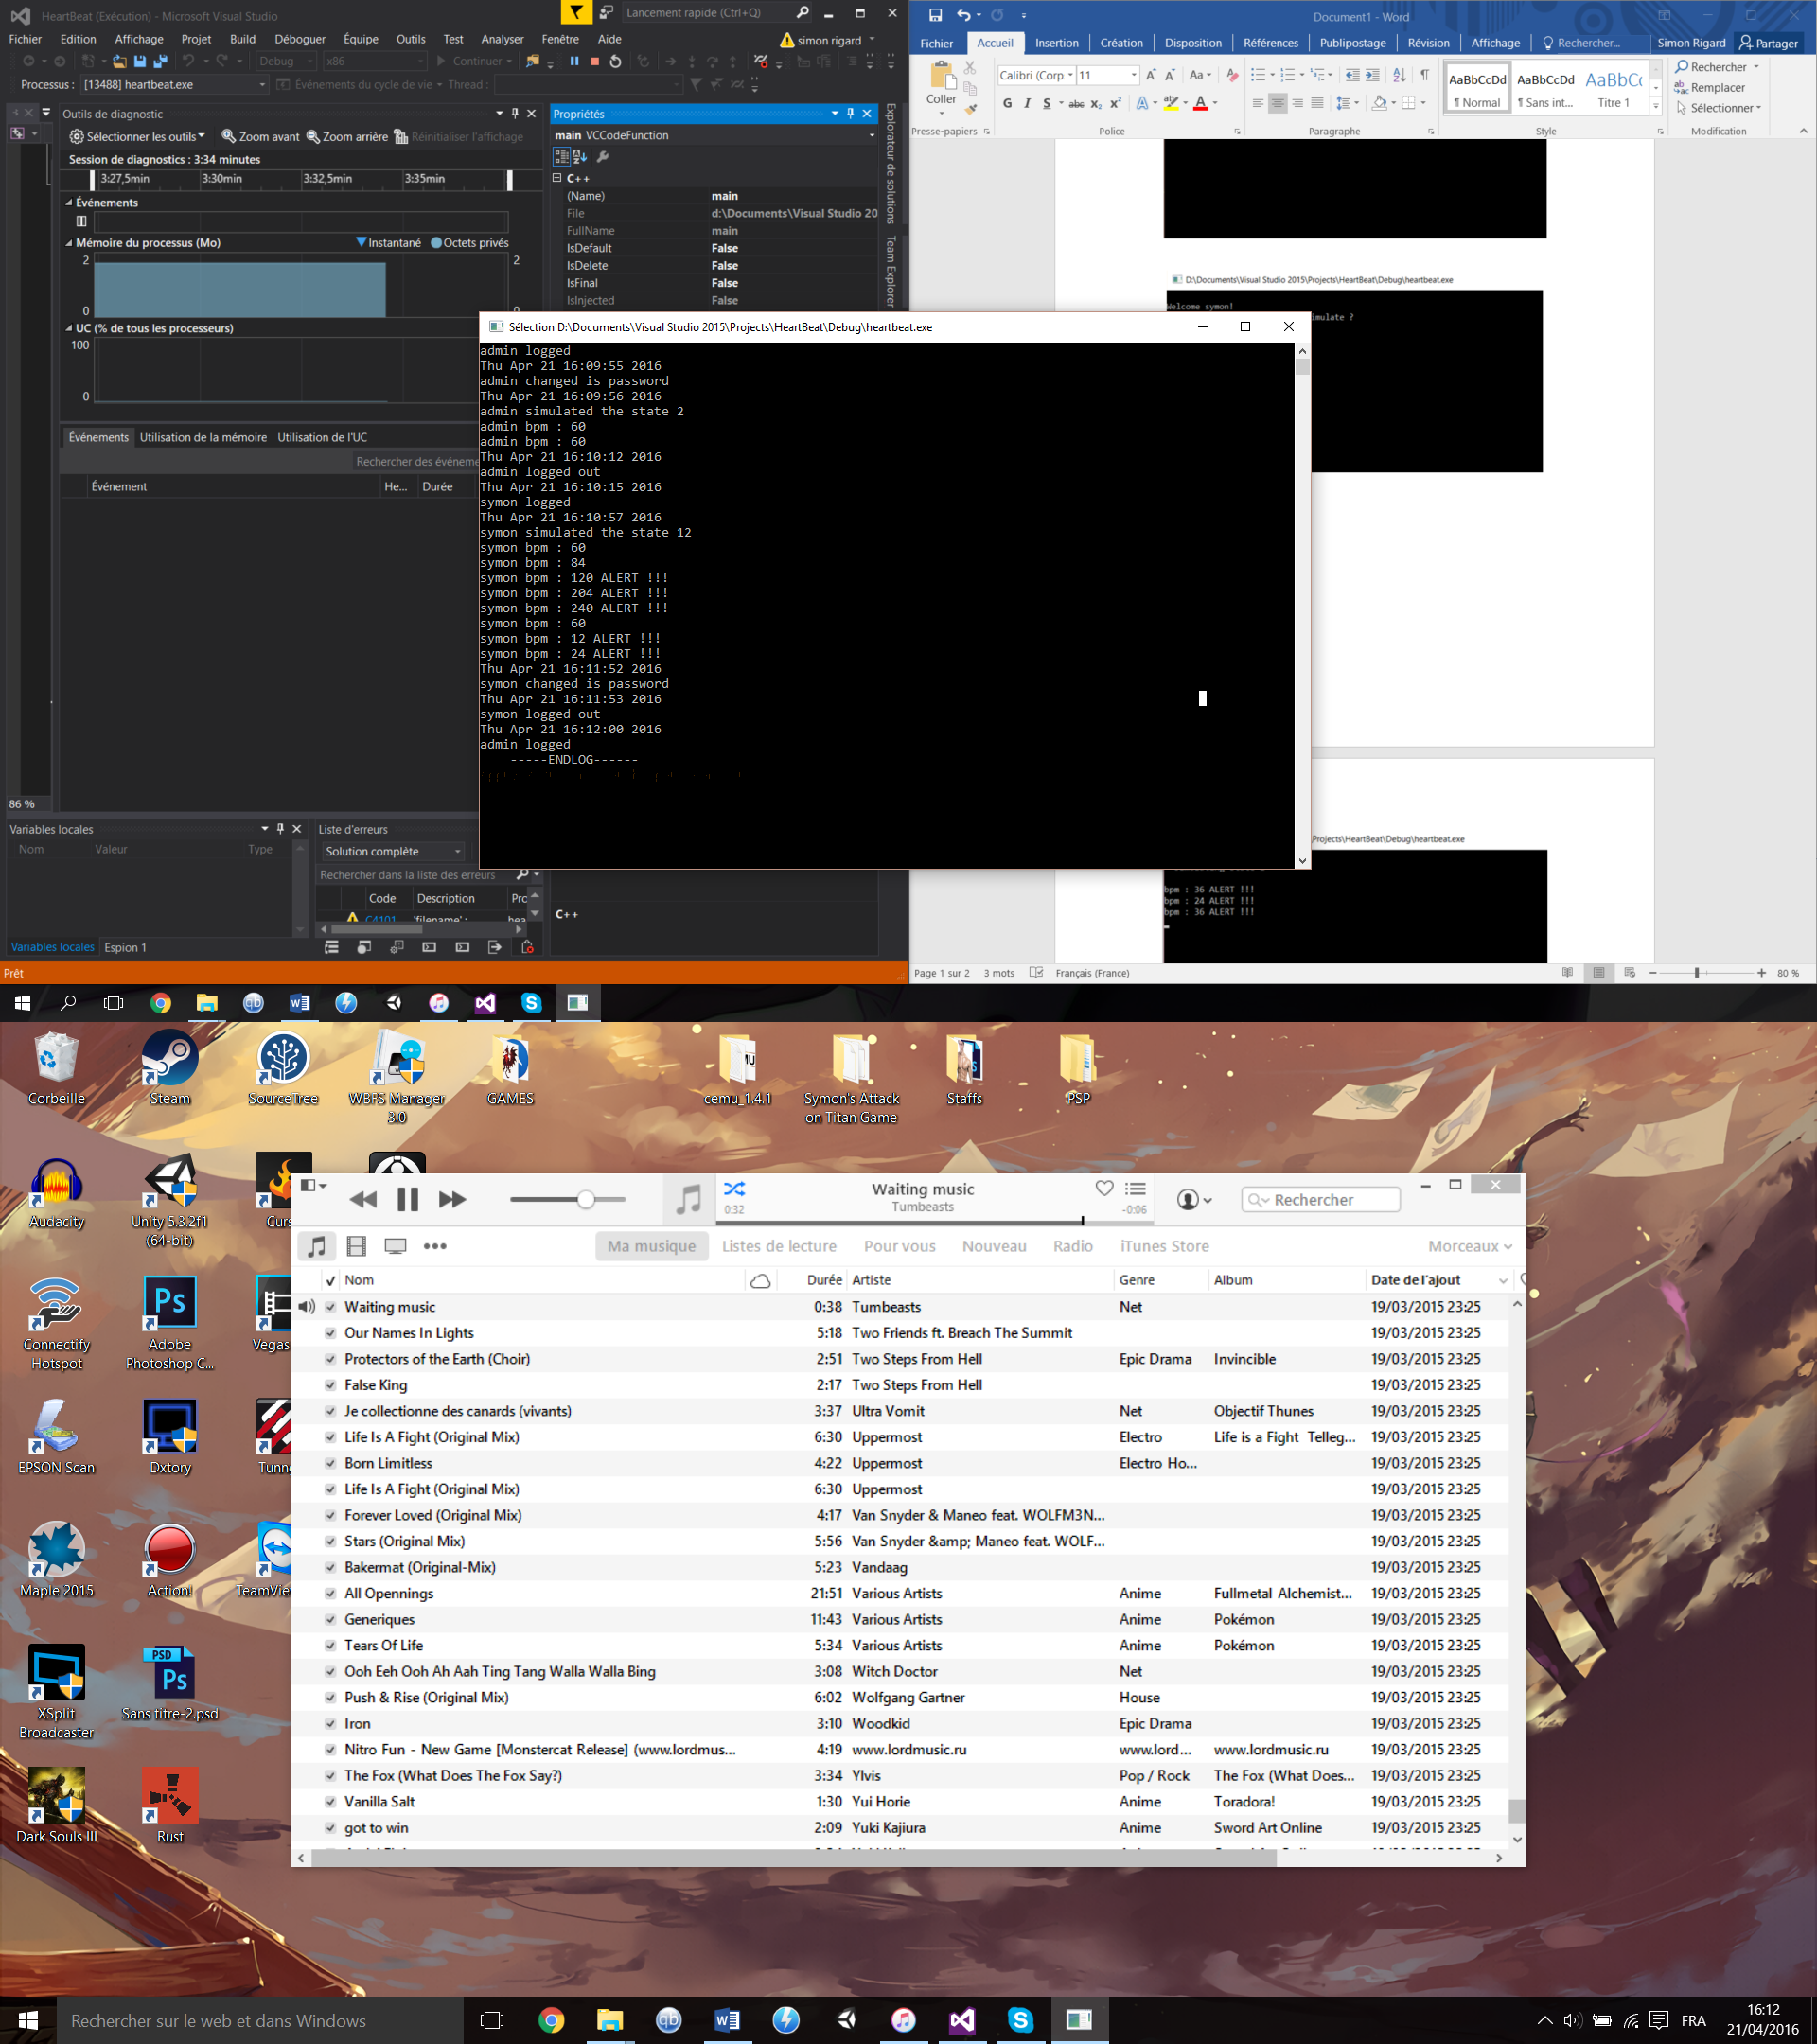

Finally, the admin can reset the log file. That removes the log file and create another one, so if the user prints it again it will be empty.

Microcontroller Code:

#include <stdio.h> /* real time clock */

void timer(void); /*Function Prototype for ISR*/

int hours, mins, secs, ticks, times; /* GLOBAL VARIABLES FOR RETURNING VALUES*/

int peaks = 0;

unsigned char *padr, *paddr, *tflg2, *pactl, *tmsk2;

char pass[10], user[10];

int i, j, ti = 0;

int tab[256][2];

unsigned char mkeyscan() //James Mc Carren mkeyscan

{

unsigned char *scsr, *scdr, data;

scsr = (unsigned char *)0x2e;

scdr = (unsigned char *)0x2f;

data = '\0';

if (((*scsr) & 0x20) != 0x0)

{

data = *scdr;

}

return(data);

}

void log(int state, int batt) //put int in the array

{

if (state == 1) // log on, put 1 in the first cell

{

tab[tab[0][0]][0] = 1;

if (strcmp(user, "admin") == 0) //put 1 if the second cell if the user is the admin

tab[tab[0][0]][1] = 1;

else

tab[tab[0][0]][1] = 0; //put 0 otherwise

}

if (state == 2) //start simulation

tab[tab[0][0]][0] = 2;

if (state == 3) // log out

{

tab[tab[0][0]][0] = 3;

if (strcmp(user, "admin") == 0)

tab[tab[0][0]][1] = 1;

else

tab[tab[0][0]][1] = 0;

}

if (state == 4) //start simulation

{

tab[tab[0][0]][0] = 4;

tab[tab[0][0]][1] = batt;

}

tab[0][0]++;

}

void seelog(void)

{

printf("\n----STARTLOG----\n");

for (ti = 1; ti < 256; ti++)

{

if (tab[ti][0] == 1) //if the cell is 1 the someone logged in

{

if (tab[ti][1] == 1)

printf("admin logged in\n");

else

printf("user logged in\n");

}

if (tab[ti][0] == 2) //if 2 it's a simulation start

{

printf("started simulation\n");

}

if (tab[ti][0] == 3) // if 3 : log out

{

if (tab[ti][1] == 1)

printf("admin logged out\n");

else

printf("user logged out\n");

}

if (tab[ti][0] == 4) //if 4 the show the bpm value stored into the second cell

{

printf("bmp: %d\n", tab[ti][1]);

}

}

printf("-----ENDLOG-----\n");

}

void remlog(void) //remove log, we put 0 in the cells

{

for (ti = 1; ti < 256; ti++)

{

tab[ti][0] = 0;

}

tab[0][0] = 1;

}

void bpm(void)

{

unsigned char *paddr, *padr, *adctl, *adr1, data;

padr = (unsigned char*)0x00;

paddr = (unsigned char*)0x01;

adctl = (unsigned char*)0x30;

adr1 = (unsigned char*)0x31;

tmsk2 = (unsigned char*)0x24;

tflg2 = (unsigned char*)0x25;

pactl = (unsigned char*)0x26;

*pactl = 0x03; /*Set prescaler to maximum*/

*tmsk2 = 0x40; /*Enable RTI interrupt*/

*paddr = 0xff; /*set port a all outputs*/

*adctl = 0x20; /*single continuous scan*/

while (!mkeyscan())

{

while (((*adctl) & 0x80) == 0x00); /*Wait for EOC*/

{

if (*adr1 > 0xfe) //if the values are sufficiently high

i = 1;

if (*padr > *adr1) //if the values are decreasing

{

if (i == 1)

{

peaks++;

i = 0;

}

}

}

if (ticks == 0 && times == 0)

{

if (secs % 5 == 0) /*print out once 5 secs*/

{

peaks = peaks * 12;

if (peaks > 100 || peaks < 40) //critical values

printf("\rbmp: %d ALERT!!!", peaks);

else

printf("\rbmp: %d", peaks);

log(4, peaks); //print in the log (in the array)

peaks = 0;

}

times = 1;

}

if (ticks == 1)

times = 0;

*padr = *adr1;

}

printf("\n\n");

}

void login(void) //ask the user to authenticate

{

user[0] = 'b'; //change values

pass[0] = 'b'; //change values

printf("\nPlease enter your username :");

scanf("%s", user);

if (strcmp(user, "admin") == 0) //if the user is admin then ask for password

{

while (strcmp(pass, "admin") != 0)

{

printf("Please enter your password :");

scanf("%s", pass);

}

}

printf("\n");

}

void main(void) //main function, menu

{

int loop = -1;

tab[0][0] = 1; //init of the first array case (location)

printf("\n Welcome to Symon's heartbeat program\n\n");

login();

log(1, 0); //print in the log (in the array)

if (strcmp(user, "admin") != 0) //only admin can acces log

printf(" (0) to logout\n (1) to simulate heartbeat\n");

else

printf(" (0) to logout\n (1) to simulate heartbeat\n (2) to see log\n (3) to remove log\n");

for (;;)

{

scanf("%d", &loop);

if (loop == 0)

{

log(3, 0); //print in the log (in the array)

login();

log(1, 0); //print in the log (in the array)

}

else if (loop == 2 && strcmp(user, "admin") == 0) //only admin can acces log

{

seelog();

printf("\n");

}

else if (loop == 3 && strcmp(user, "admin") == 0) //only admin can acces log

{

remlog();

printf("\n");

}

else

{

printf("\n");

log(2, 0); //print in the log (in the array)

bpm();

}

loop = -1;

if (strcmp(user, "admin") != 0) //only admin can acces log

printf(" (0) to logout\n (1) to simulate heartbeat\n");

else

printf(" (0) to logout\n (1) to simulate heartbeat\n (2) to see log\n (3) to remove log\n");

}

}

@interrupt void timer(void)

{

ticks++;

if (ticks == 30)

{

ticks = 0;

secs++;

if (*padr == 0)

{

*padr = 0xff;

}

else

{

*padr = 0x0;

}

}

if (secs == 60)

{

secs = 0;

mins++;

}

if (mins == 60)

{

mins = 0;

hours++;

}

if (hours == 24)

{

hours = 0;

}

*tflg2 = 0x40; /*Reset RTI flag*/

}

PC Code:

#define _CRT_SECURE_NO_WARNINGS

#include <stdio.h>

#include <stdlib.h>

#include <windows.h>

#include <time.h>

#include <conio.h>

FILE* file = NULL;

FILE* pass = NULL;

char user[10];

/*Simon Rigard*/

void log(int state, int heart) //function to print in the log

{

file = fopen("log.txt", "a");

if (state == 5) //fprintf bpm

fprintf(file, "%s bpm : %d \n", user, heart);

if (state == 6)

fprintf(file, "%s bpm : %d ALERT !!!\n", user, heart);

else

{

time_t rawtime; //to print the time in the logfile

time(&rawtime);

struct tm *info = localtime(&rawtime);

if (state == 1) //user logged

fprintf(file, "%s%s logged\n", asctime(info), user);

if (state == 2) //paswword change

fprintf(file, "%s%s changed is password\n", asctime(info), user);

if (state == 3) //simulation of state

fprintf(file, "%s%s simulated the state %d\n", asctime(info), user, heart);

if (state == 4) //user logged out

fprintf(file, "%s%s logged out\n", asctime(info), user);

}

fclose(file);

}

void bpm(int j) //calculate the bpm

{

system("cls");

printf("\n Simulating state %d\n\n", j);

int peakNb = 0; //nb of peaks

int decrease = 0; //number of consecutuve decrease

double prev = 0; //previous value

double tab[13]; //tab to get the data line by line

int i = 0;

file = fopen("data.txt", "r");

while (!_kbhit())

{

if (i > 7661) //restart when the file is finished

{

i = 0;

file = fopen("data.txt", "r");

}

fscanf(file, "%lf %lf %lf %lf %lf %lf %lf %lf %lf %lf %lf %lf %lf", &tab[0], &tab[1],

&tab[2], &tab[3], &tab[4], &tab[5], &tab[6], &tab[7],

&tab[8], &tab[9], &tab[10], &tab[11], &tab[12]); //we put the line in a tab and take only the one we want corresponding to the state

i++;

double current = tab[j];

if (prev > current) //if the values are decreasing

decrease++;

else

decrease = 0;

if (current > 2 && decrease > 1) //if the value is greater than 2 and the values are decreasing

{

peakNb++;

}

Sleep(10);

if (i % 500 == 0 && i != 0) //we do bpm : peak * 12 each 5 secs

{

int bpmin = peakNb * 12;

if (bpmin > 100 || bpmin < 40) //if bpm is in a critical state

{

FILE *file2 = fopen("log.txt", "a");

fprintf(file2, "%s bpm : %d ALERT !!!\n", user, bpmin);

printf("bpm : %d ALERT !!!\n", bpmin);

fclose(file2);

}

else

{

FILE *file2 = fopen("log.txt", "a");

fprintf(file2, "%s bpm : %d \n", user, bpmin);

printf("bpm : %d\n", bpmin);

fclose(file2);

}

peakNb = 0;

}

prev = tab[j]; //previous value

}

printf("\n");

fclose(file);

}

void login() //to authenticate the user with the pass.txt file

{

system("cls");

char password[10];

char Ruser[10], Rpassword[10];

printf(" Welcome to Symon's heartbeat program\n\n");

file = fopen("pass.txt", "r");

do

{

printf("Please enter your username : ");

scanf("%s", &user);

FILE *file2 = NULL;

file2 = fopen("pass.txt", "r");

while(strcmp(user, Ruser) != 0 && fscanf(file2, "%s %s", &Ruser, &Rpassword) != EOF); //put the first word in Ruser and the second one in Rpassword

fclose(file2);

} while (strcmp(user, Ruser) != 0); //continue until the user is found on the pass.txt

printf("Password : ");

scanf("%s", password);

fclose(file);

if (strcmp(user, Ruser) == 0 && strcmp(password, Rpassword) == 0) //good password

{

system("cls");

}

else

login(); //wrong password

log(1, 0); //print in logfile

}

void changePass() //call this fonction tho change the current user password

{

system("cls");

FILE* file3 = NULL; //To delete one line in c we must copy the whole txt in another txt and then rename it and delete the first one

FILE* file2 = NULL;

char Ruser[10]; //password of the pass file (database)

char Rpassword[10]; //user of the pass file (database)

file = fopen("pass.txt", "r+");

file2 = fopen("pass2.txt", "w");

while (fscanf(file, "%s %s", &Ruser, &Rpassword) != EOF)

{

if(strcmp(user, Ruser) != 0) //if this is the line we want to delete, we skip it

fprintf(file2, "%s %s\n", Ruser, Rpassword);

}

printf("\nEnter new Password :");

scanf("%s", &Rpassword);

fprintf(file2, "%s %s", user, Rpassword); // print the new line with the user and new password

fclose(file2);

fclose(file);

char oldname[] = "pass2.txt";

char newname[] = "pass.txt";

remove(newname); // remove the old pass.txt

rename(oldname, newname); //rename the new one to pass.txt

log(2, 0); //print password change in logfile

}

void seelog() //Call this function to print the logfile,

{

system("cls");

FILE *file;

char filename[100], c;

printf(" -----STARTLOG----");

file = fopen("log.txt", "a+");

c = fgetc(file);

printf("\n");

while (c != EOF) //print until end of file

{

printf("%c", c);

c = fgetc(file);

}

printf(" -----ENDLOG------\n");

fclose(file);

system("pause");

}

int main(int argc, char *argv[]) //main function, main menu

{

int loop = -1;

login();

while (loop != 0) //while user has not entered 0

{

if (loop == 14)

{

log(4, 0); //print in logfile

login();

}

system("cls");

printf("\nWelcome %s!", user);

if (strcmp(user, "admin") != 0)

printf("\nWhat state would you like to simulate ?\n\n (0) To quit\n (1-12) Select state\n (13) To change Password\n (14) To logout\n");

else

printf("\nWhat state would you like to simulate ?\n\n (0) To quit\n (1-12) Select state\n (13) To change Password\n (14) To logout\n (15) To see log\n (16) Reset log\n");

int state;

while (scanf("%d", &state) != 1) //fix errors when user uses letters instead of numbers

{

system("cls");

printf("\nWelcome %s!", user);

if (strcmp(user, "admin") != 0)

printf("\nWhat state would you like to simulate ?\n\n (0) To quit\n (1-12) Select state\n (13) To change Password\n (14) To logout\n");

else

printf("\nWhat state would you like to simulate ?\n\n (0) To quit\n (1-12) Select state\n (13) To change Password\n (14) To logout\n (15) To see log\n (16) Reset log\n");

int c;

while ((c = getchar()) != '\n' && c != EOF);

}

loop = state;

if (loop == 13)

changePass();

if (loop == 15 && strcmp(user, "admin") == 0) //only available for admin

seelog();

if (loop == 16 && strcmp(user, "admin") == 0) //only available for admin

remove("log.txt");

if (loop != 0 && loop < 13)

{

log(3, state); //print in logfile

bpm(state);

}

}

log(4, 0); //print in logfile

return 0;

}